**ASSIGNMENT 8 - DevOps**

Ques: Explain the aws architecture diagram below in detail, and deploy the same aws

architecture.

● For this assignment you need to take a look and study the documentation for SAM CLI,

you need to deploy a Hello, World application on aws lambda.

● Make sure when you test the lambda url it will respond as Hello, World.

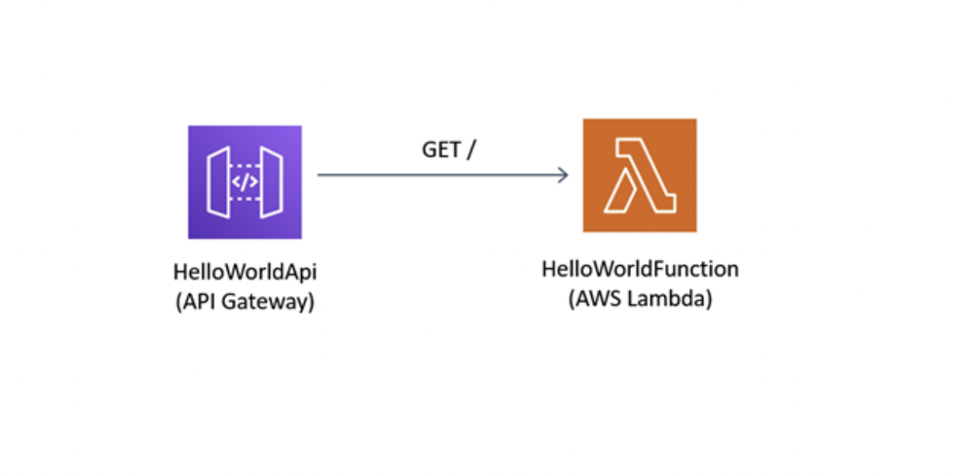

**Explanation:**

The first image represents API Gateway and the second represents the Lambda function. The API Gateway is a trigger for the lambda function invoke. When we use the API endpoint using curl, we are trying to invoke the lambda function (HelloWorldFunction). Which response back with “{"message": "hello world"}” message or any other Status code if something goes wrong. For this, to work we are first installing SAM. Later we are using sam init to make the directory which is holding the template.yaml file initialise. Later we are using the sam build to take it to the build or staged area for ready to deploy. We then use sam deploy to deploy our application in aws account. Where AWS’s cloud formation creates the lambda function and API gateway and deploys our code in the lambda function using the artifacts which were built in our build stage.

**Proof:**

**CloudFormation:**

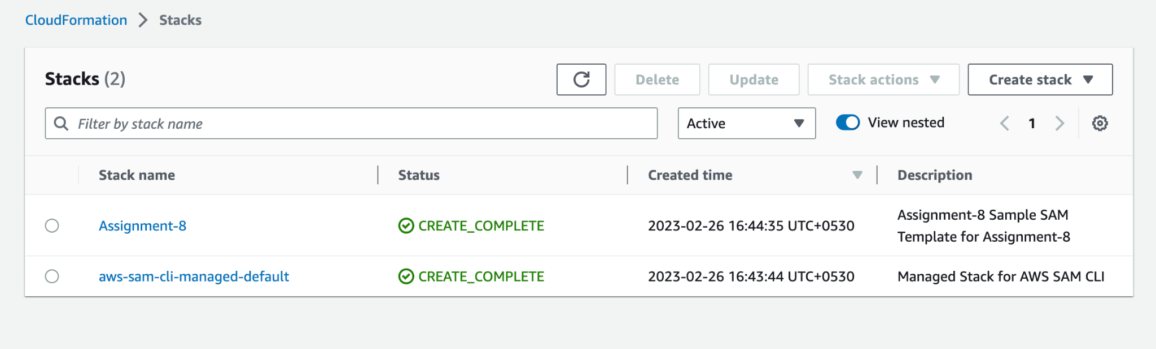

**Lambda Function:**

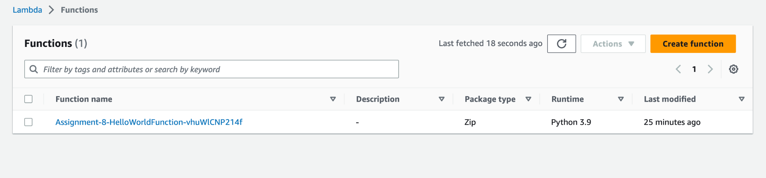

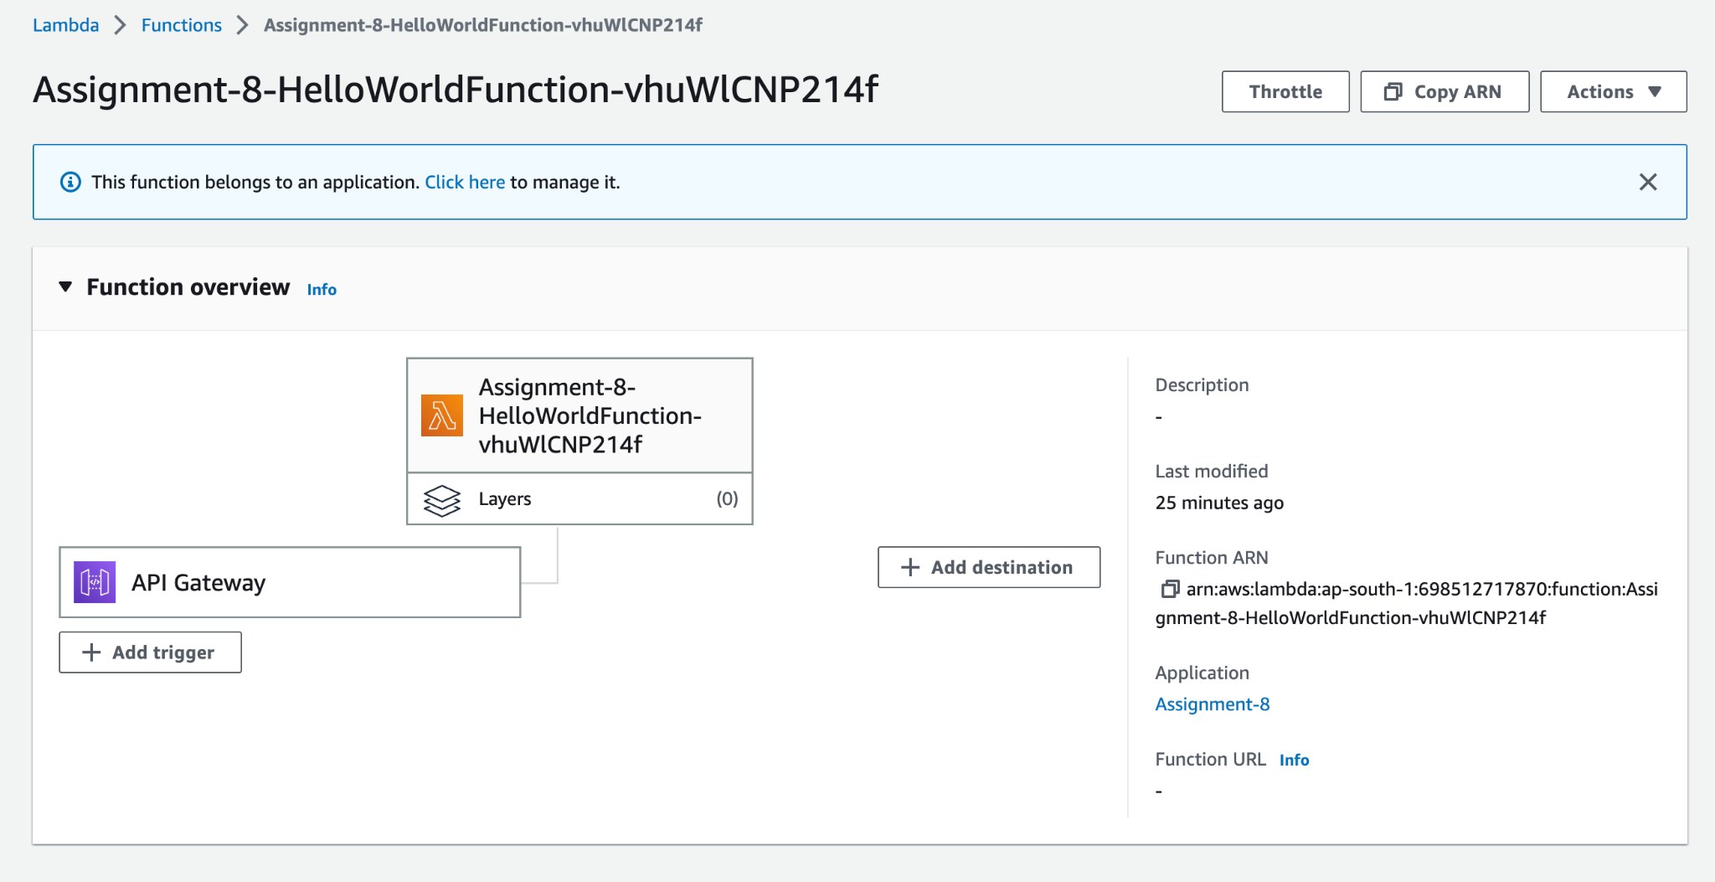

**Final Result:**

